Spike: Spike 7
Title: Non-Blocking Loop

Author: Rachel McQueenie 696737x

Goals / deliverables:
- Messaging system to facilitate communication between game objects
- Specification document that describes:
  - How messages are sent
  - How messages are received and acted upon
  - How messages are addressed
  - What content is included in a message
  - How objects register to receive messages
  - Whether a message contains information about who sent it

Technologies, Tools, and Resources used:
- Windows 7 / 8
- Visual Studio Professional 2012 / Ultimate 2012
- Spike 7

Tasks undertaken:
- Follow and complete Spike 7
- Complete the specification document (Appendix A)
- Create the Mail class
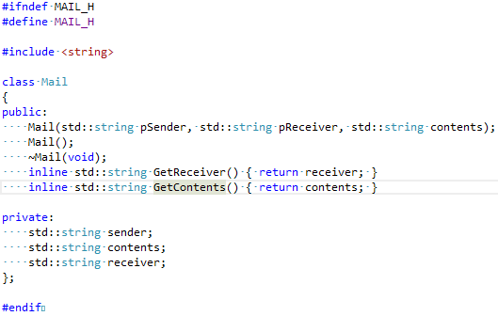
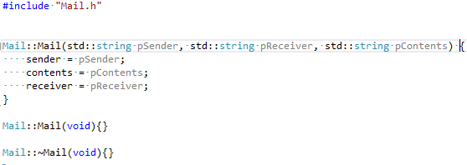

- Create the Messenger interface / abstract class
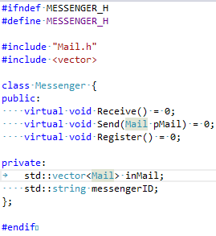
- Create the Messaging Manager
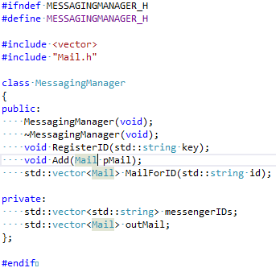
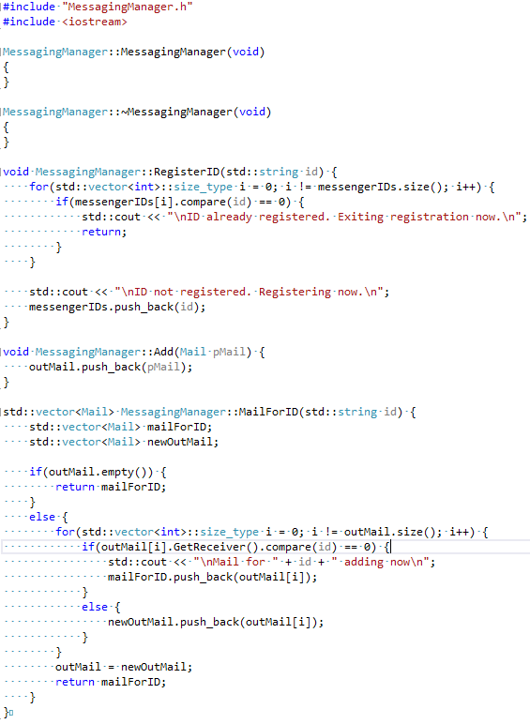
- Make the classes that use the messaging system inherit from Messenger. For demonstration purposes I'll just be using MainMenuState and AboutState.
- Implement the Messenger methods and variables in the classes (MainMenuState and AboutState) that inherit from it
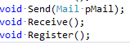
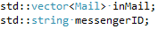
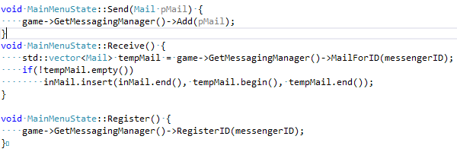
- Register the IDs in the Messenger Manager the moment the Messenger classes are created. If you look at Step 5, you'll see that if a class tries to re-register (for instance, if a class is popped from the stack and then pushed back on) it will leave a message saying it has already been registered and the program will continue to execute.
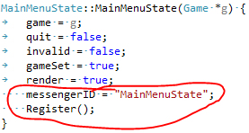
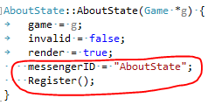
- To demonstrate the sending functionality:
  - In AboutState, send a message to MainMenuState when it is about to return to that state.
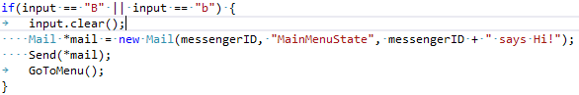
- To demonstrate the receiving functionality:
  - In MainMenuState, have the message be received at the start of the Update and then displayed to the user. Don't display anything if no mail has been received.
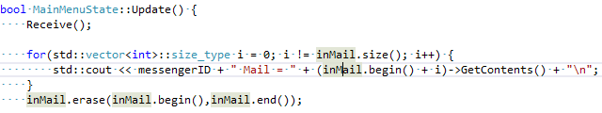
- Congratulations, you have a working Messaging system

What we found out:
How to implement a messaging system to allow the components in the game to communicate with each other. This was achieved by meeting the planned specification as best as possible given the time constraint. There were a couple of changes:
- Changed Mail to only use one Receiver and one bit of Content, instead of an array/vector/queue for both. This was to simplify implementation and also because this can also be achieved by creating Mail objects in a for loop that iterates through a number of receivers or contents.
- The Message Manager does not find a time to send the messages out. Instead, it stores them until the receiver asks if they have any mail (similar to how a receiver asks a Blackboard if they have a message). This was also to simplify implementation. It also means that any Mail that is meant to go to an unregistered ID then no problems arise – they just remain in Message Manager's outmail.
  - This was also because given the architecture, many of the receivers were being deleted and recreated, so it would be difficult for the Message Manager to know what classes existed at any moment in time, so having a time to just 'send out mail' would not have been ideal, as many messages would be undeliverable at that point.
- The 'Contents' have now changed to simple string messages that print to the screen. This is to simply demonstrate the mail was sent and received.

Some things about the system could use refinement and for those, refer to Recommendations.

Recommendations:
Obvious the final application is a bit of a 'hack job' to demonstrate it working. Ideally, the following would have been implemented:
- The messages would have contain commands for the receiver to perform, instead of simple strings that print to the screen
- All the states would be using the system, and also using it to give instructions to each other, effectively creating a decoupled application
- An expiry time for the messages so that if many are sent and then not delivered, they wouldn't clog up the Message Manager's outmail and reduce performance
Appendix A:

Specification Document:

A message will be constructed as follows:
Message(string sender, queue<string> receivers, queue<string> contents)
Parameter 'sender' is the class that is sending the message. This is so if the message fails, the Messaging Manager can send something back, telling it that it failed.
Parameter 'receiver' is a queue of strings, each specifying a class to receive the message. If any of these fail, a message will be sent back to sender saying so.
Parameter 'contents' will be the information in the message, which may include commands to execute or a number of other things.

How messages are sent:
Messages will be sent from a 'sender,' the class that is trying to communicate with another. It will send a message to a 'Message Manager' - a class that knows about all the classes that can send and receive messages – which will then proceed to determine which other class(s) will receive the message.

How messages will be received and acted upon:
The Message Manager will receive a message from a class. This message should contain an array of classes to receive the message. The Message Manager will send the message to all these classes and if it cannot find one then it will send a message to the sending class saying that it failed. If the sending fails, it will still continue to try and execute for any remaining receivers.

How messages will be addressed:
Messages will be addressed using string identifiers that the Message Manager will use to determine the receiving classes using a string comparison.

Eg:
if(“receiver” == “classname”)
send message to to Classname

What content will be included in the message:
The content included in the message will be an array of commands for the receiving classes to execute. If any fail, the Message Manager will tell the sender that they failed. It will still continue to try and execute any remaining commands.

Will a message contain information about the sender:
Yes the message will contain information about the sender and this will be used for the Message Manager to contact the sender and inform that that a message failed.

